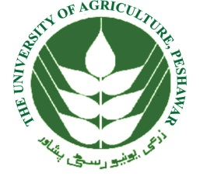 **INSTITUTE OF BUSINESS AND MANAGEMENT SCIENCES**

**THE UNIVERSITY OF AGRICULTURE, PESHAWAR**

**KHYBER PAKHTUNKHWA, PAKISTAN**

Ref. No. /IBMS /AUP Date: __________________

**TO WHOMT MAY CONCERN**

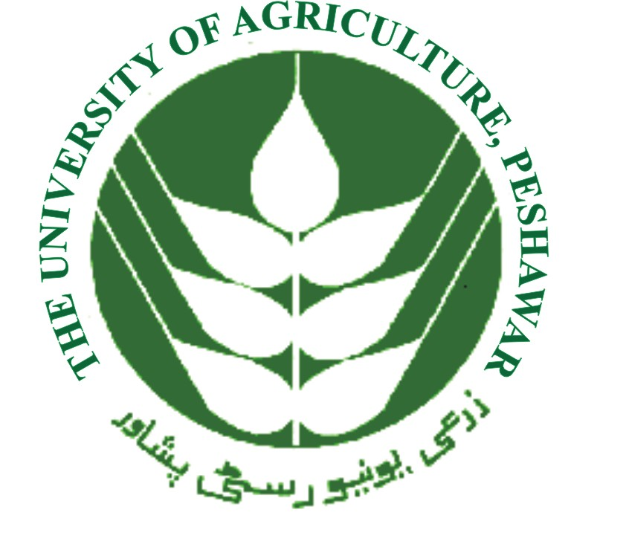

It is certified that Mr. Ijaz Ahmad S/O Abdur Rahman was a regular student of BS (IT) under University Registration No 2012-Age-U- 28072 Class No. 137 of this university for the session 2012-2016. This is to further confirm that.

1. The contents of the degree and transcript have been checked and fixed correct and genuine.
2. BS information technology degree in a 4 years full time regular degree program.
3. The examination throughout four-year degree program are held Agriculture university Peshawar.
4. The level study obtain is bachelor Degree in information technology.
5. Period of study of the degree is four (04) academic year.
6. The actual period of the degree spent by the student to obtained the degree is from 2012-2016. A regular and full-time student.
7. Agriculture university Peshawar IBMS is a public sector instruction recognize by HEC i.e. that is the regulatory and providing body of computer information technology and management sciences in Pakistan.

**HOD CS/ IT IBMS**

**Office= 92+091-9216463**